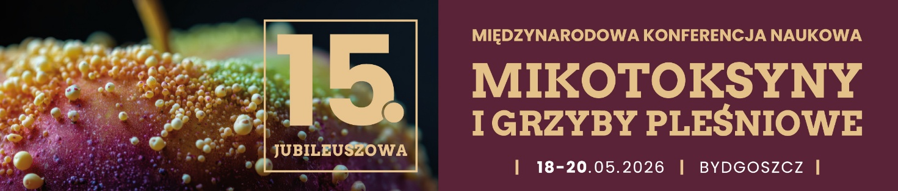
Registration Form
Surname and First Name
Institution
Street, No.
Postal Code, City, Country
Invoice details (VAT number)
Phone
Fax
E-mail
Submission of a Scientific Paper | - yes  - no
Form of Submission | - Lecture  - Scientific Presentation  - Poster
Offer for Companies | - Advertisement in the abstract book (one A4-page)  - Advertisement in the abstract book (2nd-3rd page of cover, one A4-page)  - Flyer inserted into the congress bag  - Company presentation lecture

Title of the Submission
Author(s)

Project financed from the state budget under the program of the Minister of Science and Higher Education entitled Vectors of Science, project number WNK/SP/0223/2025/01, 15th Anniversary International Conference „Mycotoxins and moulds”, project financing amount 282,920.00, total project value 360,920.00.

CONFERENCE PARTICIPANT INFORMATION CLAUSE

In accordance with Article 13 of Regulation (EU) 2016/679 of the European Parliament and of the Council of 27 April 2016 on the protection of natural persons with regard to the processing of personal data and on the free movement of such data, and repealing Directive 95/46/EC (hereinafter referred to as the GDPR), we would like to inform you that:
- The administrator of your personal data is Kazimierz Wielki University, located at Chodkiewicza 30 street, 85-064 Bydgoszcz,
- The personal data controller has appointed a Data Protection Officer to supervise the proper processing of personal data, who can be contacted via e-mail at: iod@ukw.edu.pl,
- Your personal data is processed for the purpose of registering your participation in the 15th Anniversary International Conference on Mycotoxins and Moulds, communicating with participants in order to organise the scientific event, documenting its course, including drawing up a list of participants, issuing certificates of participation, preparing conference and post-conference materials, and for archival purposes. The legal basis for the processing of personal data in this regard is Article 6(1)(e) of the GDPR (processing is necessary for the performance of a task carried out in the public interest or in the exercise of official authority vested in the controller), in connection with the Act of 20 July 2018 on Higher Education and Science and the mission pursued by the university on its basis, which is to conduct scientific activity, disseminate scientific achievements, work to raise the scientific level and professional qualifications of participants, shape civic attitudes, and participate in social development and the creation of an innovation-based economy.
Your data will also be processed for the purposes of reporting, control, and archiving related to the Conference, including the fulfilment of accounting and tax obligations arising from the use of public funds (legal basis: Article 6(1)(c) of the GDPR – processing is necessary for compliance with a legal obligation to which the controller is subject), as well as for the possible establishment, exercise, or defence of legal claims, and for analytical and statistical purposes (legal basis: Article 6(1)(f) of the GDPR – processing is necessary for the purposes of the legitimate interests pursued by the controller or by a third party).
If you give consent to receive information about conferences and events organized by the Kazimierz Wielki University in the future, the legal basis for data processing is Article 6(1)(a) of the GDPR, i.e., your consent. You may withdraw your consent at any time, which does not affect the lawfulness of processing carried out before its withdrawal,
- We do not intend to disclose your personal data to any other entities, except for those authorized under generally applicable law,
- We do not intend to transfer your data to third countries (i.e., non-EU countries) or to international organizations,
- Your personal data provided in connection with participation in the Conference will be processed for the period necessary to achieve the purposes specified in point 3), as well as for the period during which the University is required to store financial and accounting documentation and reports related to this event,
- You have the right to request from the data controller access to your personal data, their rectification, erasure, restriction of processing, data portability, as well as the right to request that the processing of your data be stopped,
- You have the right to lodge a complaint with a supervisory authority; the supervisory authority is the President of the Personal Data Protection Office,
- Providing your data is voluntary, but necessary for the purposes for which it was collected; without providing it, participation in the Conference will not be possible,
- We do not intend to use your data for automated decision-making or profiling.

Furthermore, we would like to inform you that in order to document the Conference, photographs will be taken during the event and published on the websites belonging to Kazimierz Wielki University in Bydgoszcz.

CONSENT CLAUSE – organization of conferences and events by the Kazimierz Wielki University in the future

I consent to receiving marketing and promotional information, in particular regarding conferences and events organized by UKW in the future, at the email address I have provided. I am aware that giving my consent is voluntary and that I can withdraw it at any time, which will result in the removal of my email address from the UKW database, but will not affect the processing of data prior to the withdrawal of consent.

……………………………………………..
date and signature

